

BIRLA INSTITUTE OF TECHNOLOGY AND SCIENCE, PILANI

FIRST Semester 2021-2025
“END-TO-END HYBRID INFRASTRUCTURE SETUP ON AZURE WITH RDS AND SCCM INTEGRATION”
CSIWZG628T DISSERTATION

by
Mansi Vashishth
2021wa86114

Dissertation Work carried out at Wipro Technologies, PUNE

BIRLA INSTITUTE OF TECHNOLOGY AND SCIENCE
Pilani (Rajasthan) India September 2025

CSIWZG628T DISSERTATION

“END-TO-END HYBRID INFRASTRUCTURE SETUP ON AZURE WITH RDS AND SCCM INTEGRATION”

Submitted in partial fulfilment of the requirements of

M. Tech Computing Systems & Infrastructure Degree Program

by
Mansi Vashishth
2021wa86114

Under the supervision of

Rishav Raj (Lead Administrator L2)

Dissertation work carried out at Wipro Technologies, Pune

BIRLA INSTITUTE OF TECHNOLOGY AND SCIENCE PILANI (RAJASTHAN)
September 2025

BIRLA INSTITUTE OF TECHNOLOGY AND SCIENCE PILANI

Certificate

This is to clarify that the entitled Creating End-to-End Hybrid Infrastructure Setup on Azure with RDS and SCCM Integration submitted by Mansi Vashishth Bits-ID 2021wa86114 in partial fulfilment of the requirements of CSIWZG628T Dissertation, embodies the work done by him/her under my Supervision.



Date: 15th September 2025 Signature of the supervisor Rishav Raj
Designation Lead Administrator L2

Section I
BIRLA INSTITUTE OF TECHNOLOGY AND SCIENCE, PILANI
First Semester 2024-25
CSIWZG628T DISSERTATION
MID SEMESTER EVALUATION FORM

(To be filled by the student and returned to the Supervisor) ID No. 2021wa86114 Name of Student: Mansi Vashishth Name of Supervisor: Rishav Raj
Name of the Examiner(s) Augustin Jabaraj, Preethi Manian
Dissertation Title: “End-to-End Hybrid infrastructure Setup on Azure with RDS and SCCM Integration”
Section II
(To be filled by the Supervisor in consultation with the examiner(s)) Comments on the dissertation from Examiner and Supervisor (Select Y or N)
- Quantum of work
  - Justifiable as efforts for 8 weeks duration Y / N
  - Work is in line with the commitments made in outline Y / N
- Type of work
  - Client assignment Y / N
  - Organization specific task Y / N
  - General study project such as white paper Y / N
  - Any other (kindly elaborate below in a line or two if Y Y / N
- Nature of work
  - Routine in nature Y / N
  - Involved creativity and rational thinking Y / N Kindly elaborate below if answer for above is “Y”.
It’s a detailed stud on Windows and its components especially the SQL & SCCM on Azure using the process to automate the creation of VM. The knowledge gained by Mansi with this project is very helpful to maintain Windows servers environment.

- Evaluation methodology
  - Evaluation done based on presentation to supervisor and examiner. Y / N
  - Evaluation done through Viva conducted by supervisor and examiner Y / N
  - Student regularly interacted with supervisor and incorporated. the suggestions made Y /N
  - Brief description on the report submitted, quality of presentation and suggestions given for improvement.
Good Presentation and research in Virtual Machine, All the suggestions are incorporated.
- Mid semester evaluation matrix

Tick the appropriate box (1 is lowest and 5 is the highest)
Dimension  Rank-> | 1 | 2 | 3 |  | 4 | 5
Student abilities in general
Understanding of the subject of dissertation |  |  |  |  |  | ✔
Creative thinking ability to come up with new ideas |  |  |  |  | ✔
Viva /Seminar Presentation
Communication ability |  |  |  |  |  | ✔
Organization of material |  |  |  |  | ✔
Response to review questions |  |  |  |  |  | ✔
Cohesive thinking ability |  |  |  |  |  | ✔
Report submitted
Report structure and format |  |  |  |  |  |  | ✔
Technical content of the report |  |  |  |  |  |  | ✔
Explanation on the significance of the assignment |  |  |  |  |  |  | ✔
Analysis of alternative approaches |  |  |  |  | ✔

Any other comments: NA

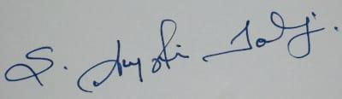
Date: 15th Sept 2025 Signature of Examiner(s) Signature of Supervisor

S.No | Content | Page Number
1. | Abstract | 7
2. | Acknowledgements | 8
2. | Objective and scope of the plan | 9
3. | Create and Azure Subscription | 10
4. | Resource group, Virtual Network and Virtual Machine | 11- 12
5. | Tools used in this project | 12
6. | Steps and Process to create VM setup using Terraform | 13-15
7. | Verify the VM created | 16
8. | Connect VM via RDP | 17-18
9. | Install ADDS and promote the server as Domain Controller | 19-21
10. | Create a DNS server | 22
11. | Create OU & Users | 23
12. | SQL server Setup | 24-26
13. | Script to perform SQL and SSMS setup | 27
14. | Terraform Script to Create 3 Virtual Machines | 28-34
15. | Conclusion | 36
16. | Detailed Plan of the work | 37
17. | Reference Links | 38
18. | Check list of items for report | 39

Abstract

In this project we demonstrate the deployment of 3 windows server infrastructure in Microsoft Azure with the help of tools like Terraform and PowerShell for automate the process. This infrastructure included three Windows Server VMs, Resource group, virtual network, subnet, public Ips all these were provisioned through Terraform.

Post-deployment, the first VM was promoted to Domain Controller includes roles like AD DS and DNS then second VM was initially joined to domain and then configured SQL Server setup using automated PowerShell scripts and the third VM was added as domain member server using CLI. This project demonstrates the approach in which Terraform provisions infrastructure and automated server role configuration using PowerShell that enables a scalable and production ready setup.

ACKNOWLEDGEMENTS

I would like to thank my project Supervisor Rishav Raj for this effort for his effort, guidance, help and patience. He has been extremely helpful, supportive, and cooperative throughout the project. His valuable comments and suggestions have been very helpful in enhancing the quality of work.
I would like to express my sincere gratitude towards my examiners Augustin Jabaraz and Preethi Manian for examining my progress despite their business schedule.
I am also thankful to WIPRO TECHNOLOGIES for giving me such opportunity for training in M. Tech Computing System and Infrastructure Degree Program and providing all the resources required for this dissertation.
I am grateful to Bits Pilani and the training department for all their efforts in organizing this course.

Objective and scope of the plan

Objective:
Main Objective is to bring all the infrastructure of an existing organization under a single domain using windows technologies based on cloud computing using Terraform and PowerShell maintain the infrastructure in compliance all the time.

Scope of the plan:

The scope of the plan is to create a windows domain with various windows technologies that are required for an organization using Cloud Computing.

- Get an Azure subscription
- The automation and deployment of three virtual machines on Azure using Terraform.
- Deploy the Windows Machines
- Create Domain
- Promote the VM0 to domain controller.
- Deploy all the applications/ roles using PowerShell.

This project can be used to train my team on Azure and automation which can be show cased to the client and get the contract of cloud-based projects that are the handled by client.

Create an Azure Account

Creating an Azure account is as easy as you create outlook account. Organizations will buy subscriptions to maintain the resources and secure the environment.

Here in this project, I have used Azure free subscription also called as Student trail.
Create an Outlook account, and then use the outlook account to create azure free subscriptions by signing up at https://portal.azure.com/#home

Below is the home screen of Azure after sign-up

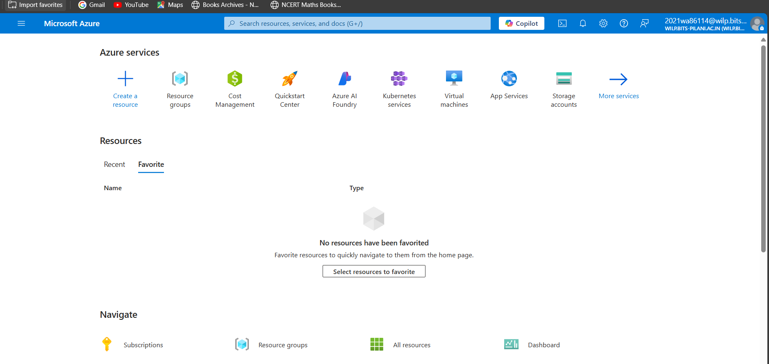

Resource group:

A Resource Group in Azure is nothing but a logical container where you are creating your Azure resources. That holds all your Azure Resources. A resource group created in a specific region can contain the resources created in the other regions. There is no restriction on that.
Resource groups are also called the central unit that acts like a logical container that holds all the Azure resources. In my case name of resource is MTECH.

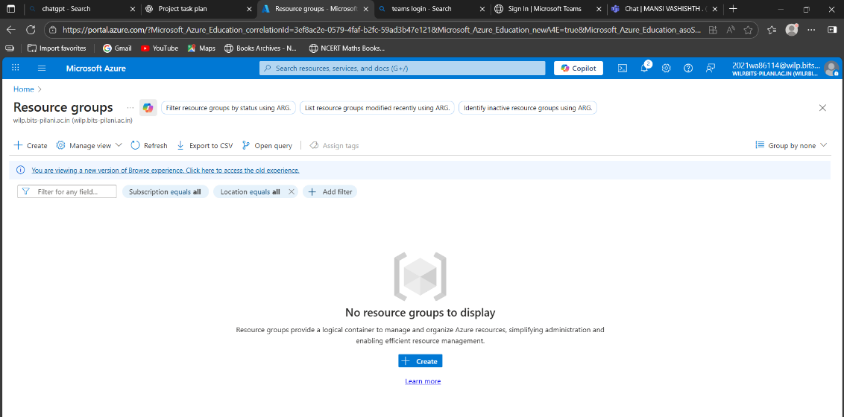

Virtual Network:

Azure Virtual Network (VNet) is the core building block for creating private networks inside Azure. It allows different Azure resources—like Virtual Machines (VMs)—to talk to each other securely, as well as connect to the internet or you’re on-premises environment.

You can think of a VNet as similar to the networks we use in traditional data centers, but it also comes with Azure’s advantages like easy scaling, high availability, and strong isolation.

By default, everything inside a VNet can connect out to the internet. If you want the internet or outside users to reach a resource inside the VNet, you need to give it a public IP address or put it behind a load balancer. You can also manage outgoing connections using public IPs or load balancers.

I have named the VNet as MTech_Network.

Virtual Machine:

Azure Virtual Machines (VMs) are a type of cloud-based computer that you can create and use whenever you need. Unlike other ready-made Azure services, VMs give you more freedom and control over the system because you decide how it is set up, which software to install, and how it is maintained.
The main advantage of using a VM in Azure is that you don’t need to buy or manage the physical servers yourself. Azure takes care of the underlying hardware, and you just focus on using the machine. However, you are still responsible for things like updating the operating system, installing applications, and keeping it secure.
There are different situations where Azure VMs are useful:
- Development and Testing – Developers can quickly spin up VMs with the exact settings they need to build and test their applications.
- Running Applications – If your app has changing demand, you can add more VMs when traffic is high and remove them when it’s low. This way, you only pay for what you actually use.
- Extending Your Datacenter – VMs in Azure can connect with your company’s on-premises network, making it easy to expand your IT infrastructure without buying new physical servers.

Here, I have created 3 VM’s named as: mansivm-0, mansivm-1, mansivm-2.

Tools Used in This Project
- Terraform – This is a tool that helps us create servers and networks in Azure automatically, instead of doing everything by hand.
- Microsoft Azure Portal – The website where we can see, manage, and monitor all the resources we create in Azure.
- Azure Virtual Machines (VMs) – These are like computers running in the cloud. We used them for Domain Controller and SQL Server.
- PowerShell – A scripting tool we used to run commands for setting up the Domain Controller, joining other VMs to the domain, and installing SQL.
- Remote Desktop (RDP) – This allows us to log in to our virtual machines and work on them as if they were normal computers.

Steps and Process to Create the setup now using Terraform

  - Created Infrastructure with Terraform – Used Terraform to automatically create 3 virtual machines inside an Azure Virtual Network:
- Prework: a. Install and setup Terraform in local machine.
b. Download Azure CLI.
c. If using VS Code, then install extension – HashiCorp Terraform for smooth setup.

- Created a folder name: F:\2021wa86114\azure-3vm-project to store script and terraform scripts.
- Open Command Prompt as admin and navigate to the folder path where you have stored the scripts and .tf code.
- Login Azure using: az login
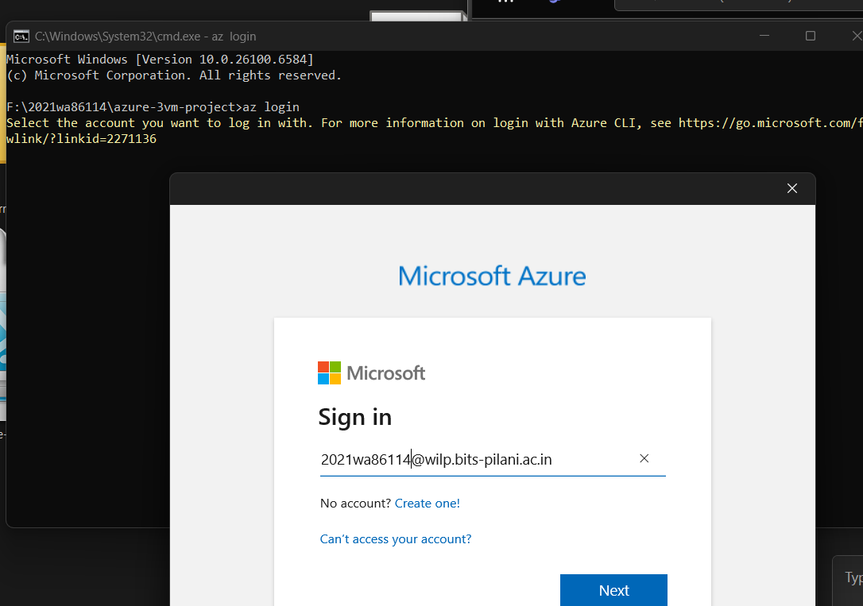

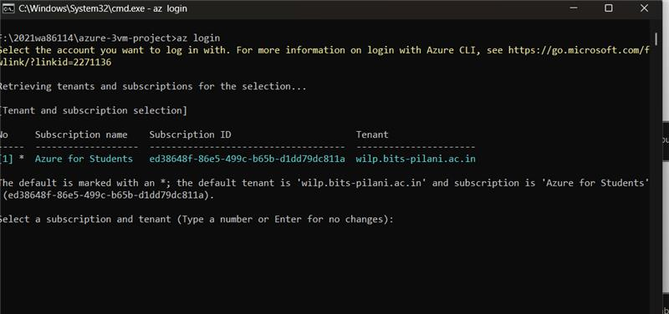

***I have given below names in configuration setup:

- Resource group name: MTECH
- Azure region for resources: Central India
- VNet Name: MTech_Network
- Subnet Name: subnet-project
- Number of Virtual Machines to create: 3
- Domain name: bits.com
***** I have documented the terraform code for this process on page no 28

- Initialize Terraform: Run terraform init
First, I ran terraform init to set up Terraform and download the required Azure provider. 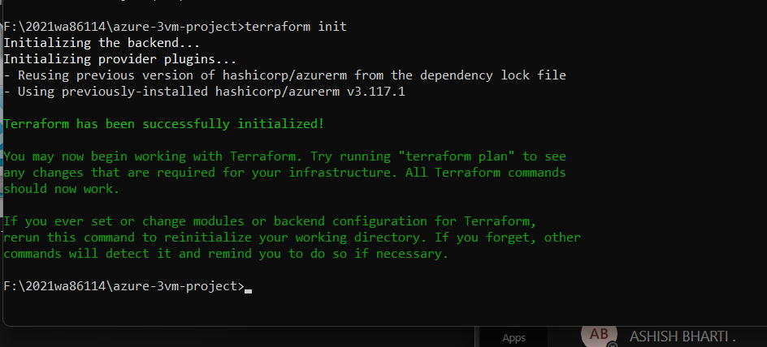

- Terraform Plan: Run terraform plan
Then, I used terraform plan to check what resources Terraform would create in Azure. This step helps to make sure everything is correct before actually creating the resources.
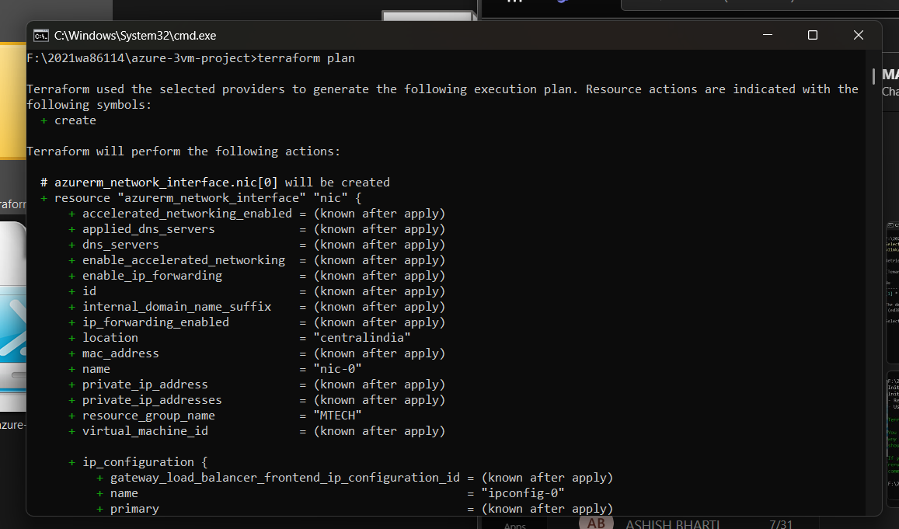
- Terraform Apply: terraform apply -auto-approve
Next, I ran terraform apply to actually create the resources. Terraform created a resource group, virtual network, subnet, network security groups, public IPs, network interfaces, and three virtual machines.
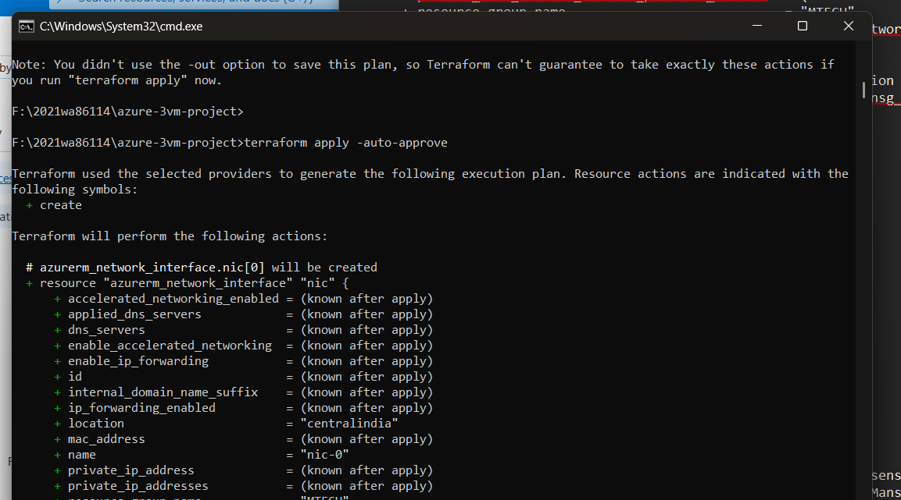

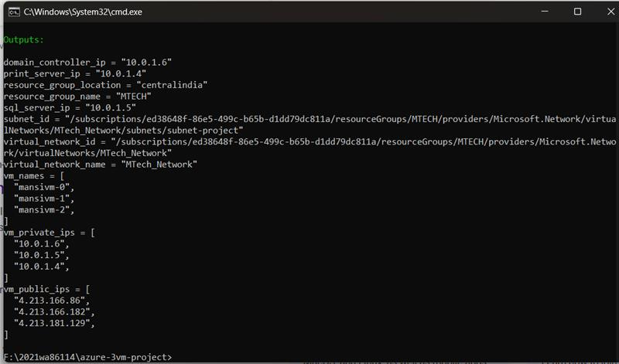

Post terraform apply: Verify Resources

After running the Terraform script, I went to the Azure portal to confirm that all three virtual machines and the related network resources were created correctly.
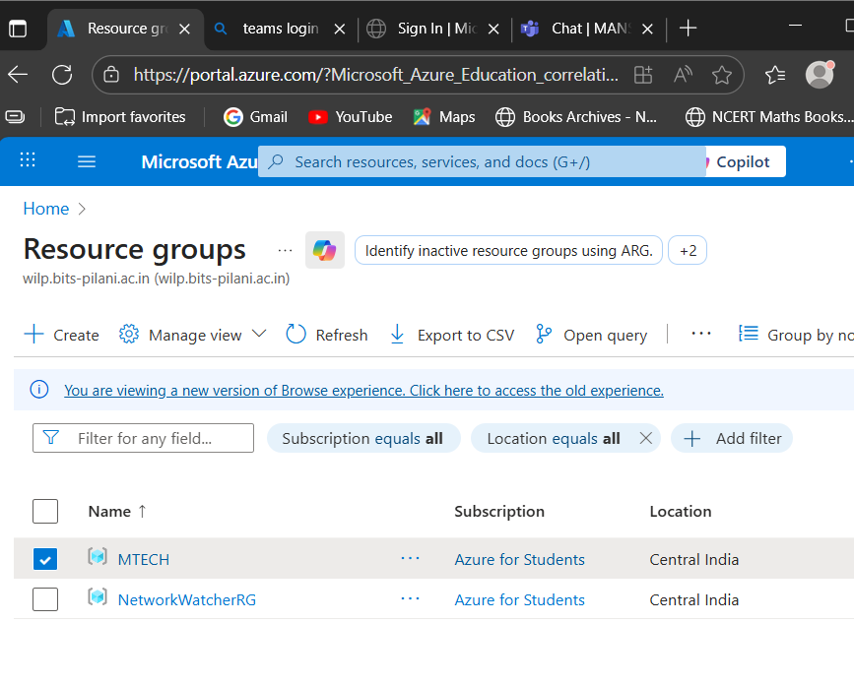

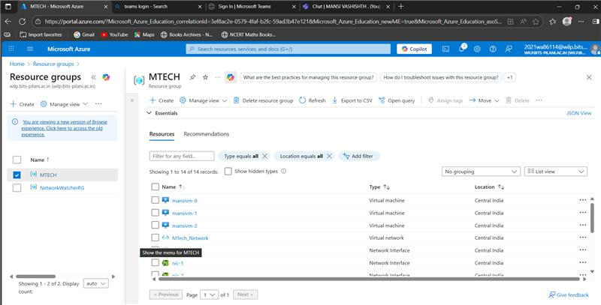

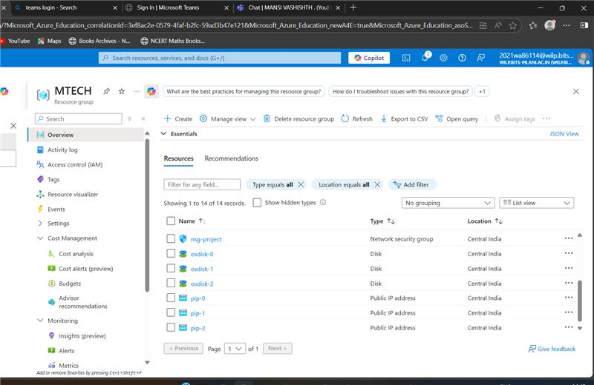
Promote Mansivm-0 to act as Domain Controller

Each operating system uses its own way (protocol) to connect to a virtual machine. In this project, the VMs are running Windows Server 2019 Datacenter. Windows servers use Remote Desktop Protocol (RDP), which works on port 3389, to connect.
To log in, we can simply download the RDP file of the VM from the Azure portal and connect by entering the admin username and password that were set while creating the VM.

- Step 1: Connect Virtual machine – mansivm-0 via rdp
Click on server name -> connect -> Download RDP file - connect

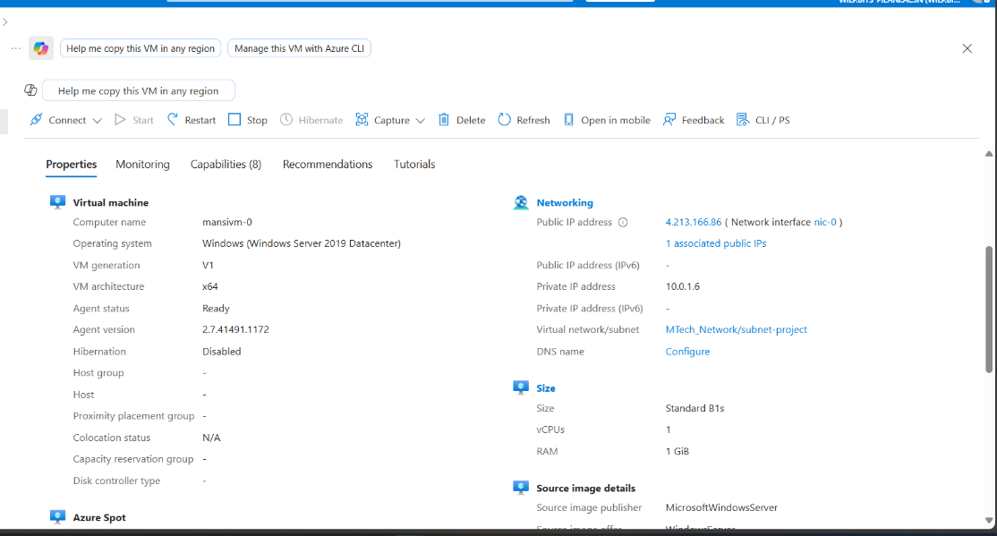

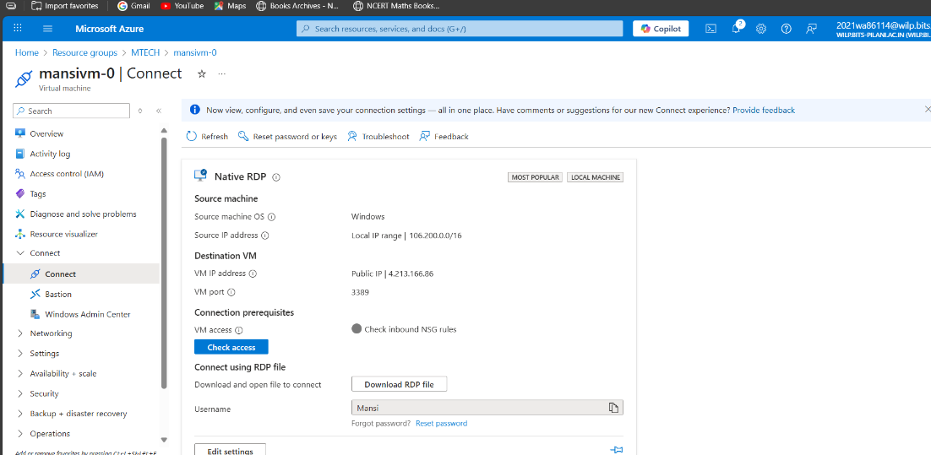

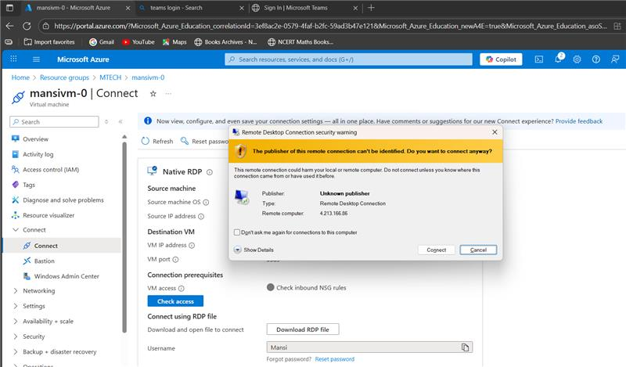

I am able to get into the server successfully. Since its free trail account the firewalls are already configured by Azure and Microsoft Defender is the antivirus tool installed in the server.

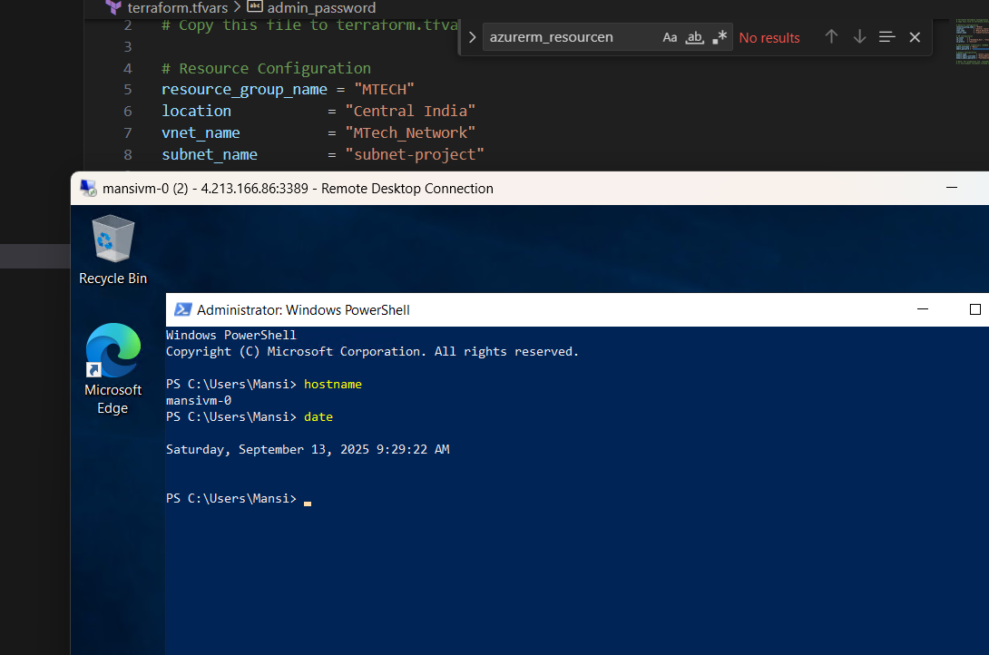

Install ADDS and promote the server as Domain Controller
A Domain Controller (DC) is a special server in a network that manages security and user access. It checks login requests, stores user accounts, and makes sure security rules are followed. In Windows environments, the Domain Controller works with Active Directory, which is the main service used to organize and control users and resources in a domain.

Open Server Manager à Add Roles and Features à Jump to the server roles à Select Active Directory Domain Services role à Add all the features à Click Next à Install

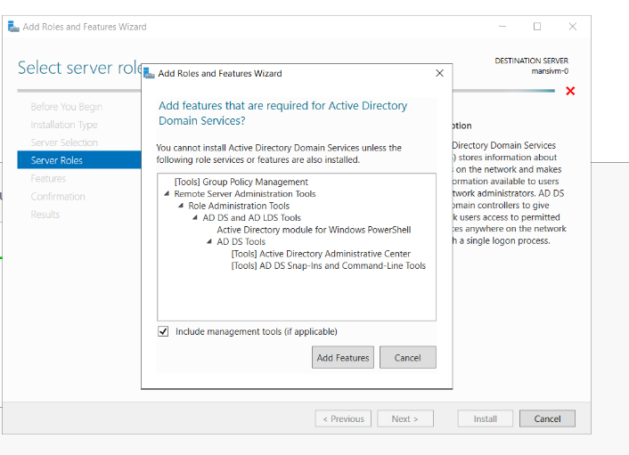

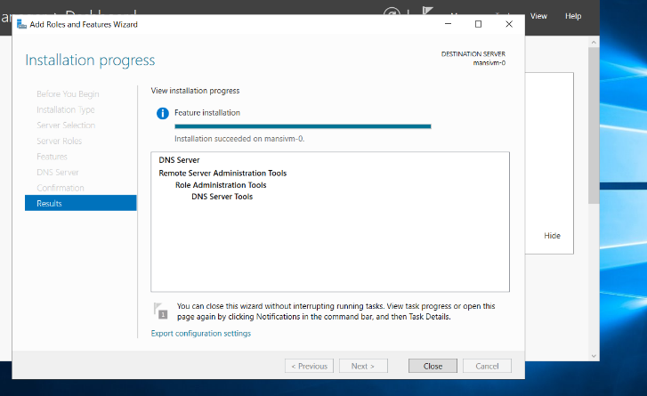

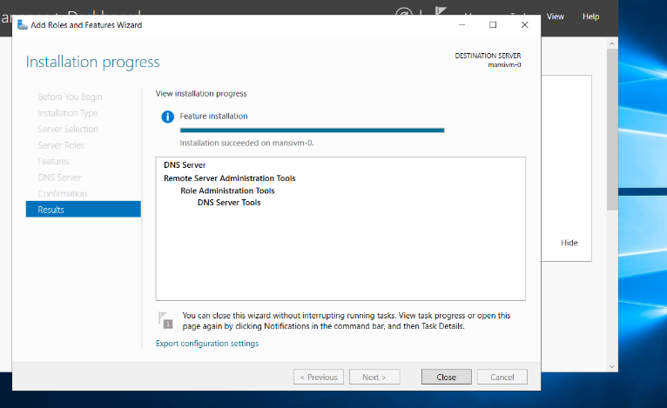

After installing the AD DS role, the server can be promoted to a domain controller.
Since I was creating a new domain, I chose the option “Add a new forest” and named my domain bits.com

Next, I set a password for Active Directory recovery and continued with the default settings. Once the installation finished, the server rebooted, and after restart, a new domain called bits.com was successfully created, managed by the forest root domain controller (DC).

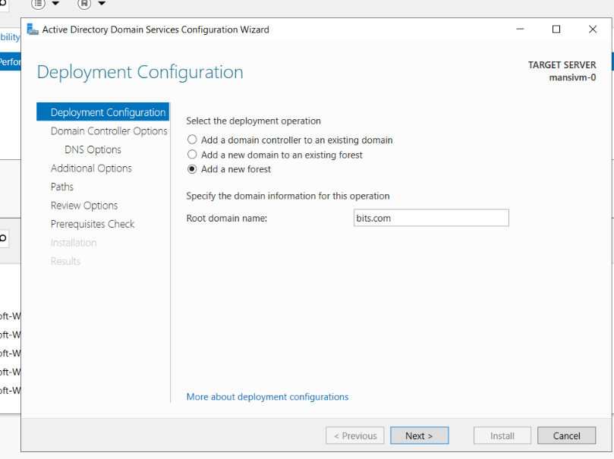

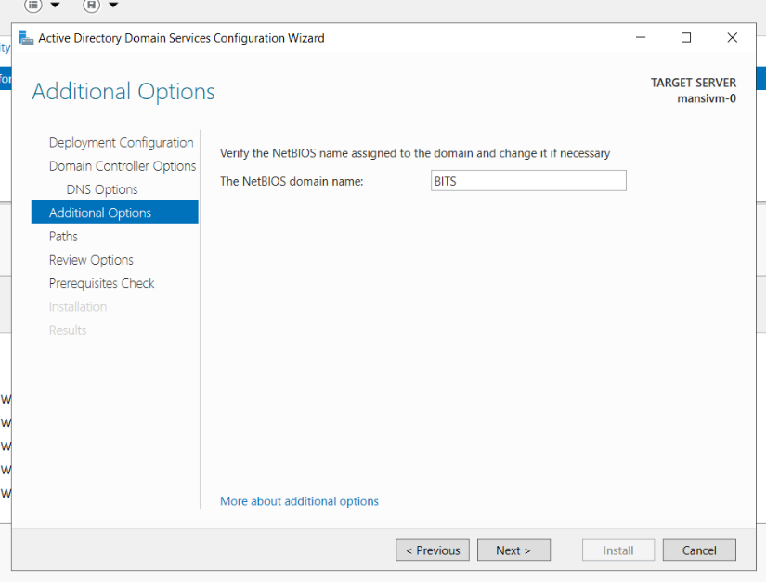

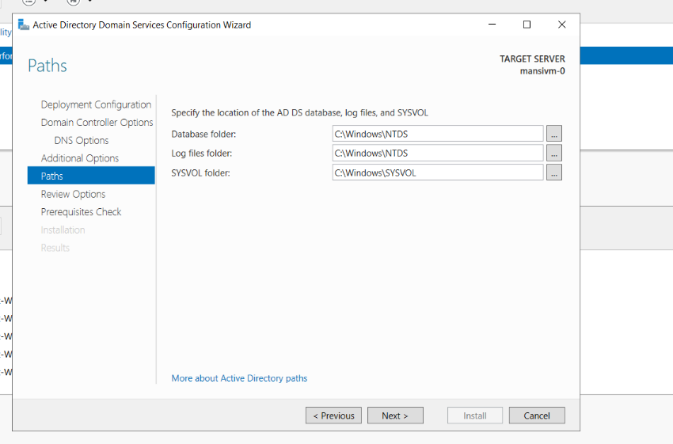

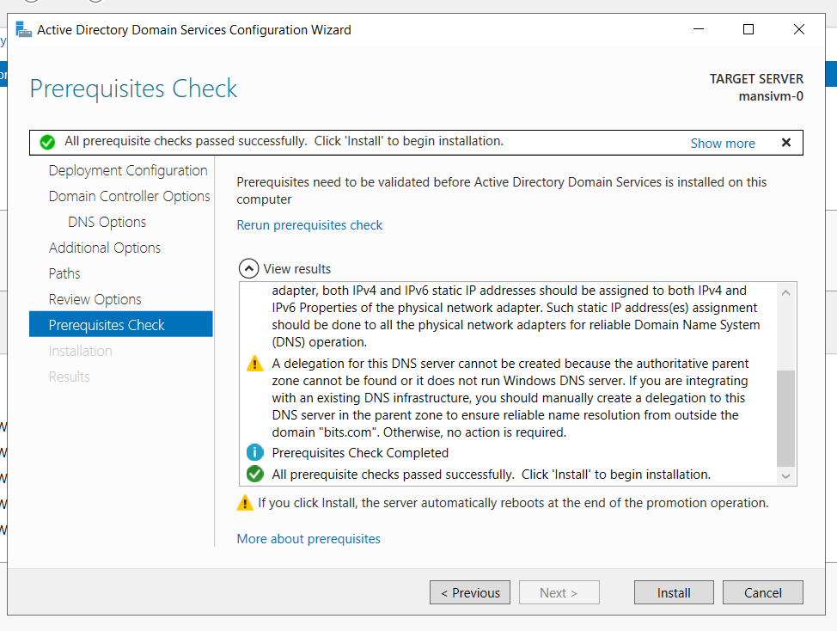
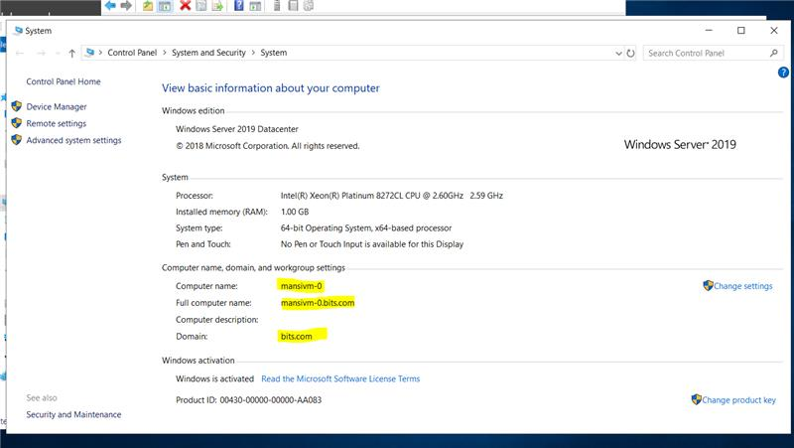

Create a DNS server:
he Domain Name System (DNS) is like a naming service for computers and servers. It makes it possible to use simple names instead of remembering long numbers (IP addresses). For example, instead of typing an IP, we just use a name like server1 or google.com.
When we install DNS, the server can match names to the right IP addresses. This way, users can easily find and connect to other systems without needing to know the actual numbers.
The process of installing DNS is almost the same as installing ADDS, but here we just select DNS. After the server restarts, the same domain controller also works as a DNS server.
In small setups, one server can handle both ADDS and DNS. But in bigger companies, there are usually separate servers dedicated just for DNS management.
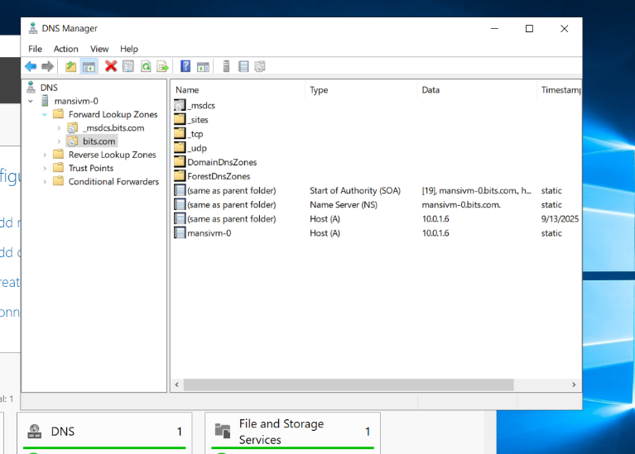

An OU is like a folder inside Active Directory where you can keep users, groups, and computers of an organization. It helps in keeping everything organized.
The main use of an OU is that administrators can apply policies (rules) or permissions to it. For example, you can create an OU for each department like HR, IT, or Finance, and then apply specific rules only to that department.

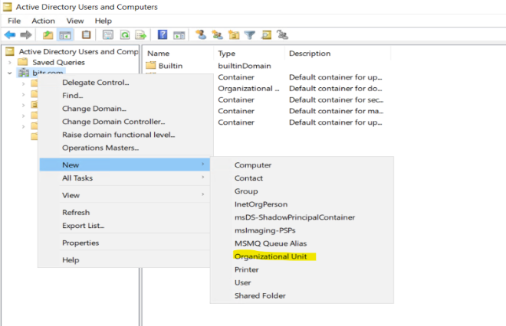
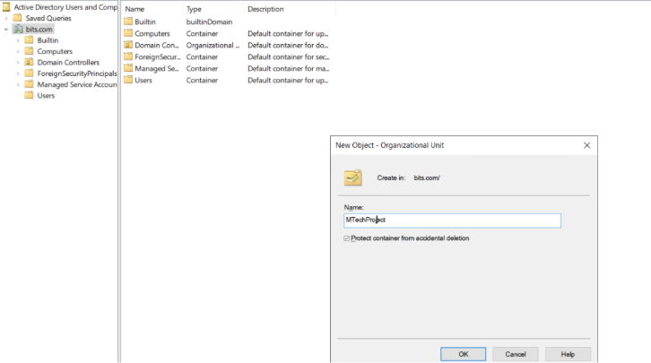

Once the OU is ready, create users to manage the environment, services and applications. Below are the users that I have created in this OU.
- Mansi Vashishth
- SCCMAdmin
- sqladmin

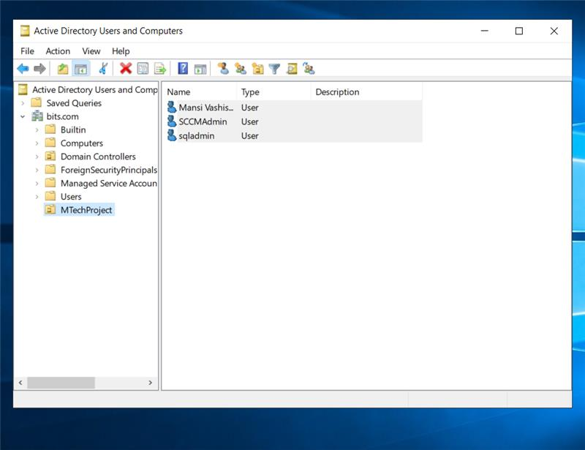
I have added all the users to Domain Admins so that they will have admin access over the Domain.

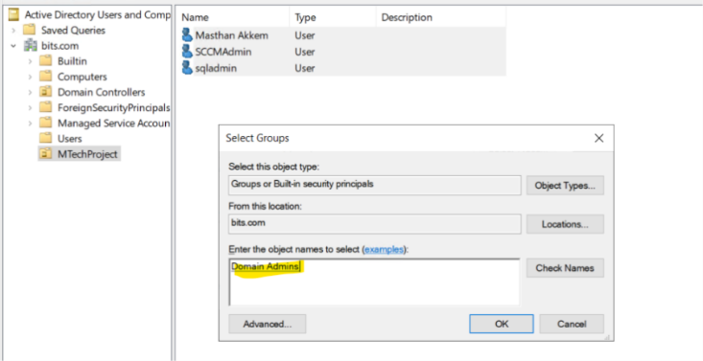

As server is successfully promoted as domain controller. Now I have joined the rest two vms to domain -bits.com and configure the roles as planned.
Provided Admin access to the servers for the accounts that which we created.
- Mansi Vashishth has full control over Domain Controller (DC).
- SCCMAdmin has the full control over SCCM server.
- Sqladmin has full control over SQL server.
Configure SQL Server setup on mansivm-1

- Login to server via rdp.
- Now, to join server to domain bits.com we need to configure VM 0 ip as DNS server in rest of the servers by using cli.
$DomainName = "bits"
$DC_IP = "10.0.1.6"
# Set DNS to point to the domain controller
Set-DnsClientServerAddress -InterfaceAlias "Ethernet" -ServerAddresses $DC_IP
- Once, DNS configured successfully. Run below command on vm to join to the domain.
# Join domain
Add-Computer -DomainName "bits.com" -Credential(Get-Credential) -Restart
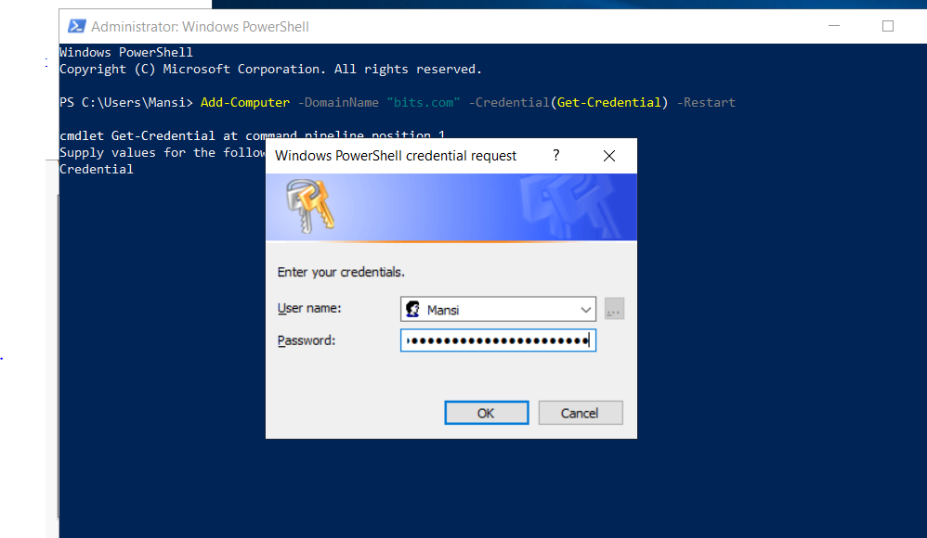
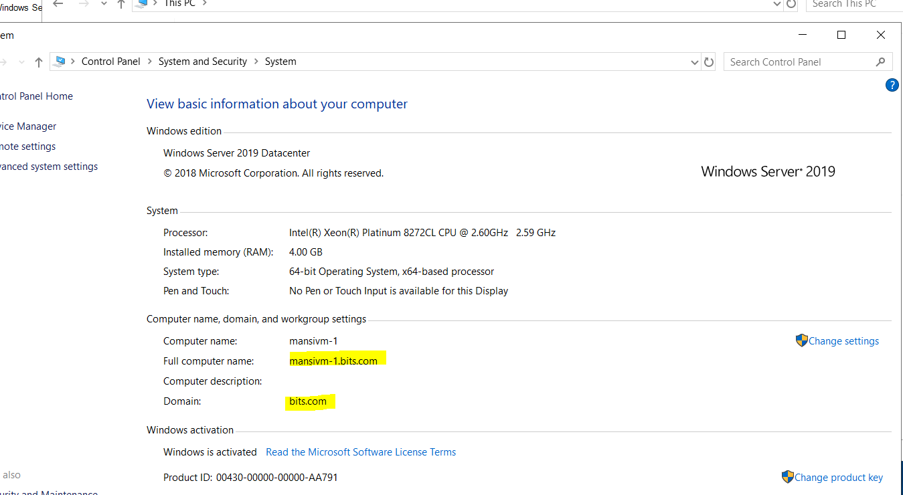

SQL Server 2019

SQL Server 2019 is Microsoft’s database software. It is used to store, manage, and organize data so that applications can use it. For example, if you have an application that keeps records of students, employees, or sales, SQL Server is the place where all that data is saved.
It is reliable, secure, and can handle large amounts of information. SQL Server 2019 also comes with many features to make searching, analysing, and protecting data easier.

SQL Server Management Studio (SSMS)
SSMS is a free tool provided by Microsoft to work with SQL Server. It gives you a simple window where you can:
- Connect to your SQL Server,
- Create or manage databases,
- Run queries (ask questions from the database),
- Backup or restore data, and
- Monitor the server.

In this project, I installed SQL Server 2019 Express
Instead of doing the setup manually, I used a PowerShell script to make the process faster and easier.

The script performed the following steps automatically:
- Downloaded the SQL Server 2019 Express installer.
- Installed SQL Server with the required configuration.
- Opened the firewall port (1433) so that SQL Server can be accessed.
- Downloaded and installed SQL Server Management Studio (SSMS), which is the tool used to manage SQL databases.
- Cleaned up the temporary setup files after installation.

By using the script, the installation became more reliable and repeatable. I didn’t need to click through the installer manually; everything was done in one go.

I have created the script and paster under C:\Scripts of VM1
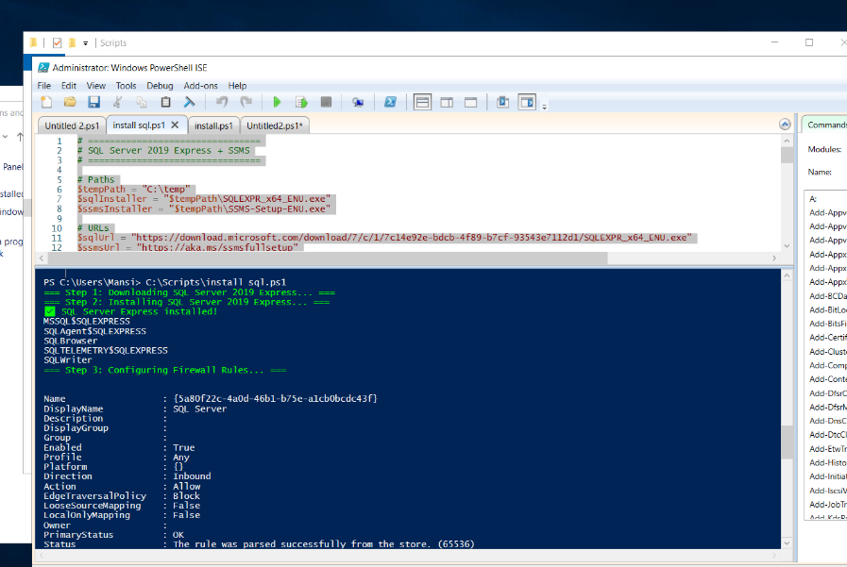

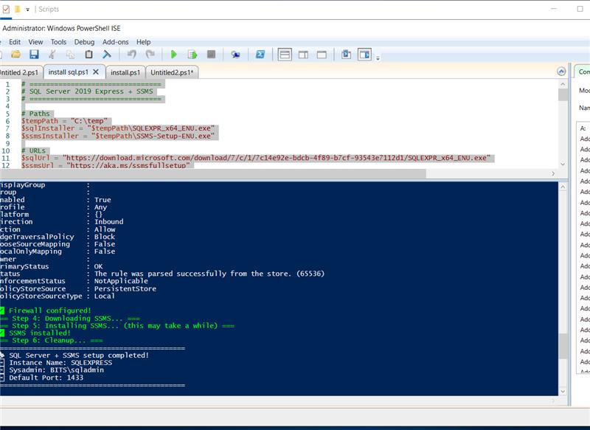

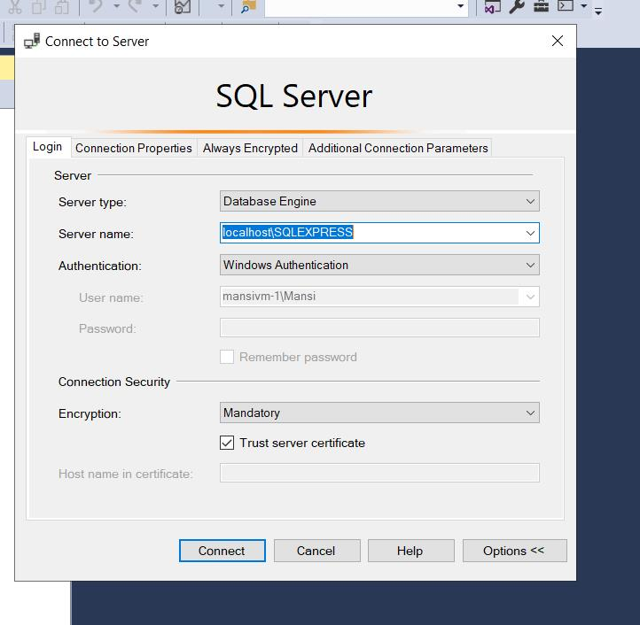

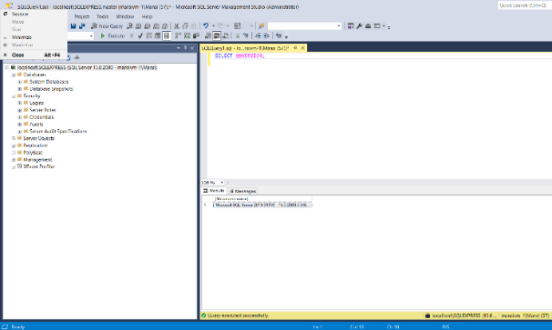
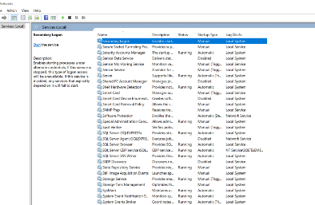

***** Terraform Script to Create 3 Virtual Machines

To automate the setup in Azure, I used Terraform.
Terraform is an Infrastructure as Code (IaC) tool that allows us to define and create cloud resources through code.
Below is the Terraform script that was used in this project to create:
- A Resource Group
- A Virtual Network and Subnet
- A Network Security Group with rules
- Public IPs and Network Interfaces
- Three Virtual Machines (VM0 as Domain Controller, VM1 as SQL Server, and VM2 as RDS)

Main.tf:

// ---------------------------
// Provider Configuration
// ---------------------------
terraform {
required_version = ">= 1.0"
required_providers {
azurerm = {
source = "hashicorp/azurerm"
version = "~> 3.0"
}
}
}
provider "azurerm" {
features {
resource_group {
prevent_deletion_if_contains_resources = false
}
}
}
// ---------------------------
// Resource Group
// ---------------------------
resource "azurerm_resource_group" "rg" {
name = var.resource_group_name
location = var.location
}
// ---------------------------
// Virtual Network
// ---------------------------
resource "azurerm_virtual_network" "vnet" {
name = var.vnet_name
address_space = ["10.0.0.0/16"]
location = azurerm_resource_group.rg.location
resource_group_name = azurerm_resource_group.rg.name
}
resource "azurerm_subnet" "subnet" {
name = var.subnet_name
resource_group_name = azurerm_resource_group.rg.name
virtual_network_name = azurerm_virtual_network.vnet.name
address_prefixes = ["10.0.1.0/24"]
}
// ---------------------------
// Network Security Group
// ---------------------------
resource "azurerm_network_security_group" "nsg" {
name = "nsg-project"
location = azurerm_resource_group.rg.location
resource_group_name = azurerm_resource_group.rg.name
}
// NSG Rules for RDP access
resource "azurerm_network_security_rule" "rdp" {
name = "RDP"
priority = 1000
direction = "Inbound"
access = "Allow"
protocol = "Tcp"
source_port_range = "*"
destination_port_range = "3389"
source_address_prefix = "*"
destination_address_prefix = "*"
resource_group_name = azurerm_resource_group.rg.name
network_security_group_name = azurerm_network_security_group.nsg.name
}
// NSG Rules for Active Directory
resource "azurerm_network_security_rule" "ad_dns" {
name = "AD-DNS"
priority = 1001
direction = "Inbound"
access = "Allow"
protocol = "Tcp"
source_port_range = "*"
destination_port_range = "53"
source_address_prefix = "10.0.1.0/24"
destination_address_prefix = "*"
resource_group_name = azurerm_resource_group.rg.name
network_security_group_name = azurerm_network_security_group.nsg.name
}

resource "azurerm_network_security_rule" "ad_ldap" {
name = "AD-LDAP"
priority = 1002
direction = "Inbound"
access = "Allow"
protocol = "Tcp"
source_port_range = "*"
destination_port_range = "389"
source_address_prefix = "10.0.1.0/24"
destination_address_prefix = "*"
resource_group_name = azurerm_resource_group.rg.name
network_security_group_name = azurerm_network_security_group.nsg.name
}
resource "azurerm_network_security_rule" "ad_ldaps" {
name = "AD-LDAPS"
priority = 1003
direction = "Inbound"
access = "Allow"
protocol = "Tcp"
source_port_range = "*"
destination_port_range = "636"
source_address_prefix = "10.0.1.0/24"
destination_address_prefix = "*"
resource_group_name = azurerm_resource_group.rg.name
network_security_group_name = azurerm_network_security_group.nsg.name
}
resource "azurerm_network_security_rule" "ad_kerberos" {
name = "AD-Kerberos"
priority = 1004
direction = "Inbound"
access = "Allow"
protocol = "Tcp"
source_port_range = "*"
destination_port_range = "88"
source_address_prefix = "10.0.1.0/24"
destination_address_prefix = "*"
resource_group_name = azurerm_resource_group.rg.name
network_security_group_name = azurerm_network_security_group.nsg.name
}
// NSG Rules for SQL Server
resource "azurerm_network_security_rule" "sql_server" {
name = "SQL-Server"
priority = 1005
direction = "Inbound"
access = "Allow"
protocol = "Tcp"
source_port_range = "*"
destination_port_range = "1433"
source_address_prefix = "10.0.1.0/24"
destination_address_prefix = "*"
resource_group_name = azurerm_resource_group.rg.name
network_security_group_name = azurerm_network_security_group.nsg.name
}
// Associate NSG with subnet
resource "azurerm_subnet_network_security_group_association" "nsg_association" {
subnet_id = azurerm_subnet.subnet.id
network_security_group_id = azurerm_network_security_group.nsg.id
}
// ---------------------------
// Public IPs for VMs
// ---------------------------
resource "azurerm_public_ip" "pip" {
count = var.vm_count
name = "pip-${count.index}"
location = azurerm_resource_group.rg.location
resource_group_name = azurerm_resource_group.rg.name
allocation_method = "Static"
sku = "Standard"
}
// ---------------------------
// Network Interfaces
// ---------------------------
resource "azurerm_network_interface" "nic" {
count = var.vm_count
name = "nic-${count.index}"
location = azurerm_resource_group.rg.location
resource_group_name = azurerm_resource_group.rg.name

ip_configuration {
name = "ipconfig-${count.index}"
subnet_id = azurerm_subnet.subnet.id
private_ip_address_allocation = "Dynamic"
public_ip_address_id = element(azurerm_public_ip.pip.*.id, count.index)
}
}
// ---------------------------
// Virtual Machines (Windows Server 2019 Datacenter)
// ---------------------------
resource "azurerm_windows_virtual_machine" "vm" {
count = var.vm_count
name = "${var.vm_prefix}-${count.index}"
location = azurerm_resource_group.rg.location
resource_group_name = azurerm_resource_group.rg.name
size = count.index == 1 ? "Standard_B2s" : "Standard_B1s" # SQL = 2 CPU, others = 1 CPU
admin_username = var.admin_username
admin_password = var.admin_password

network_interface_ids = [
element(azurerm_network_interface.nic.*.id, count.index)
]
os_disk {
name = "osdisk-${count.index}"
caching = "ReadWrite"
storage_account_type = "Standard_LRS"
}
source_image_reference {
publisher = "MicrosoftWindowsServer"
offer = "WindowsServer"
sku = "2019-Datacenter"
version = "latest"
}
tags = {
Environment = "Production"
Project = "MTech-3VM"
Role = count.index == 0 ? "DomainController" : count.index == 1 ? "SQLServer" : "PrintServer"
}
}

** Varibles.tf:

// ---------------------------
// Variables Configuration
// ---------------------------
variable "resource_group_name" {
description = "Name of the resource group"
type = string
default = "MTECH"
}
variable "location" {
description = "Azure region for resources"
type = string
default = "Central India"
}
variable "vnet_name" {
description = "Name of the virtual network"
type = string
default = "MTech_Network"
}
variable "subnet_name" {
description = "Name of the subnet"
type = string
default = "subnet-project"
}
variable "vm_count" {
description = "Number of virtual machines to create"
type = number
default = 3
}
variable "vm_size" {
description = "Size of the virtual machines"
type = string
default = "Standard_B2s"
}
variable "admin_username" {
description = "Administrator username for VMs"
type = string
default = "admin"
}
variable "admin_password" {
description = "Administrator password for VMs"
type = string
sensitive = true
}
variable "vm_prefix" {
description = "Prefix for VM names"
type = string
default = "mansivm"
}
variable "domain_name" {
description = "Domain name for Active Directory"
type = string
default = "bits.com"
}

variable "domain_admin_username" {
description = "Domain administrator username"
type = string
default = "DomainAdmin"
}

variable "domain_admin_password" {
description = "Domain administrator password"
type = string
sensitive = true
}

Conclusion

- First, I took an Azure subscription and prepared the cloud environment.
- I analysed the requirements and wrote the Terraform code for infrastructure.
- Using terraform apply, I created 3 virtual machines (VMs) in Azure.
- I configured the first VM as a Domain Controller by installing AD DS and DNS.
- I joined the 2nd and 3rd VMs to the created domain.
- On the second VM, I installed SQL Server using PowerShell script.
- The third VM was successfully joined to the domain and kept for extra roles (like SCCM)

Detailed Plan Of The Work

S.No: | Tasks or subtasks to be done  (be precise and specific) | Planned duration (in weeks) | Specific Deliverable in terms of the project
1 | Requirement Gathering and analysis | Week 1 | Gather all the requirements and make a blueprint of the project
2 | Infrastructure Setup with Terraform and azure subscription | Week 2,3 & 4 | Started with creating an active Azure subscription and Wrote Terraform code to automatically create the required resources.
3 | Virtual Machines Creation | Week 5 | Deployed 3 Windows Server 2019 VMs in Azure using Terraform.
4 | Create Domain Controller Setup | Week 6 | Promote one of the VM as a Domain Controller (AD DS + DNS)
5 | Domain Join | Week 7 | Join other VMs to domain.
6 | Create a Database to store organization data | Week 8 &9 | Installed and configured SQL Server 2019 on one of the VM using PowerShell scripts

Reference Links:

https://learn.microsoft.com/en-in/training/paths/microsoft-azure-fundamentals-describe-cloud-concepts/

https://wipro.udemy.com/course/az900-azure/

https://wipro.udemy.com/course/windows-server-2019-administration-h/

Check list of items for report:

- Is the Cover page in proper format? Y / N
- Is the Title page in proper format? Y / N
- Is the Certificate from the Supervisor in proper format? Has it been signed? Y / N
- Is Abstract included in the Report? Is it properly written? Y / N
- Does the Table of Contents’ page include chapter page numbers? Y / N
- Is Introduction included in the report? Is it properly written? Y/N
- the Pages numbered properly? Y / N
- Are the Figures numbered properly? Y / N
- Are the Tables numbered properly? Y / N
- Are Are the Captions for the Figures and Tables proper? Y / N
- Are the Appendices numbered? Y / N
- Does the Report have Conclusions/ Recommendations of the work? Y / N
- Are References/ Bibliography given in the Report? Y / N
- Have the References been cited in the Report? Y / N
- Is the citation of References/ Bibliography in proper format? Y / N

